Project Submission
Project -1: Brain Task
Step 1
Fork GitHub and copy it locally
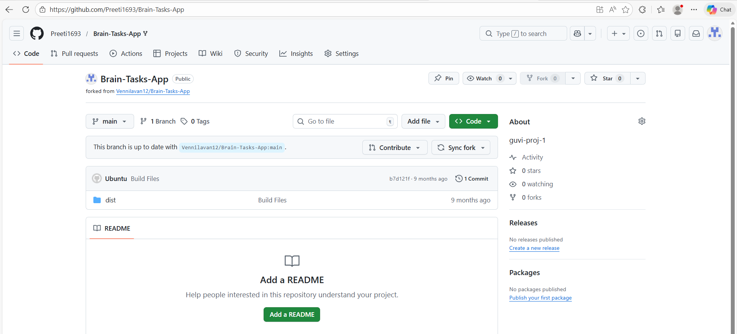
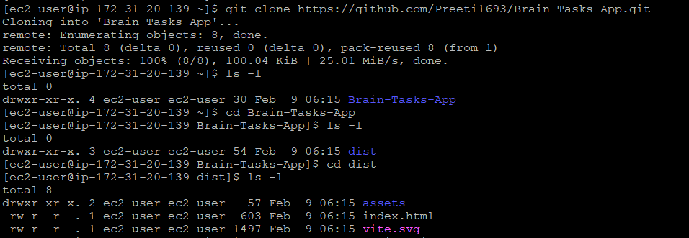

Step 2
Dockerize the application by creating Dockerfile and build for manual check
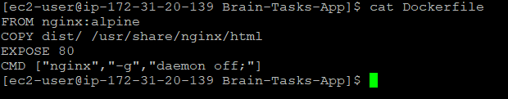

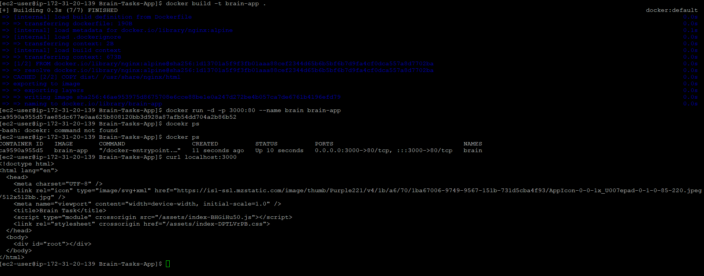
Application Successfully runs in port 3000
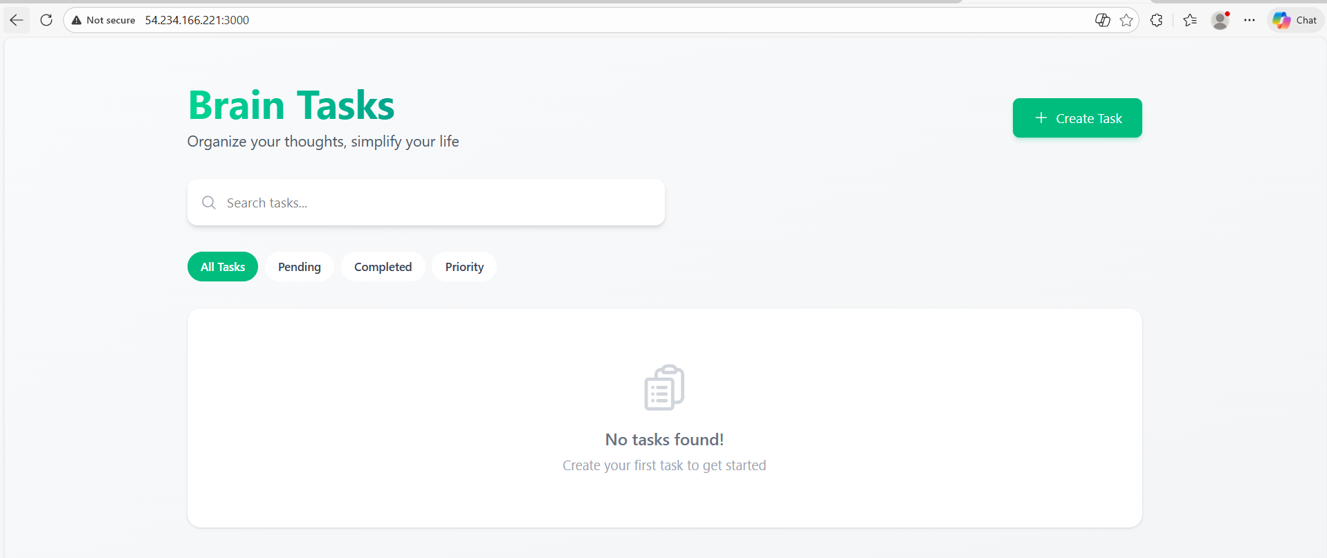

Automation Starts
Step 3
ECR created
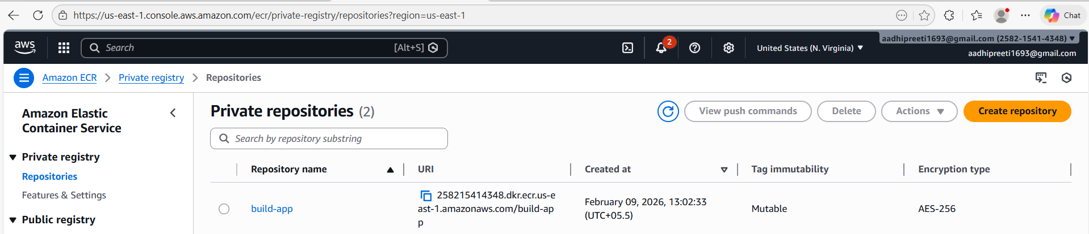

Step 4 buildspec, deployment and service files are created
Buildspec.yml
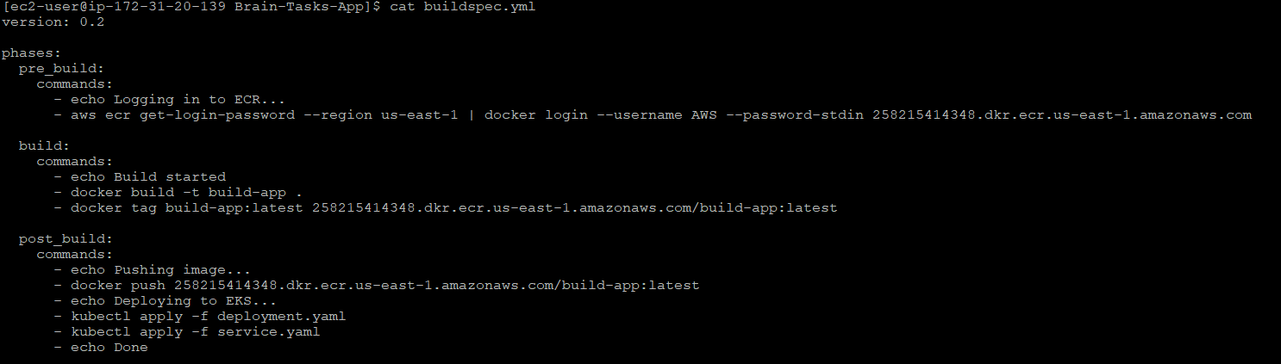
Deployment.yaml
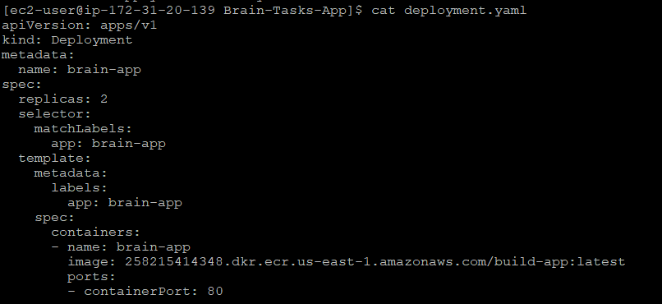
Service.yaml
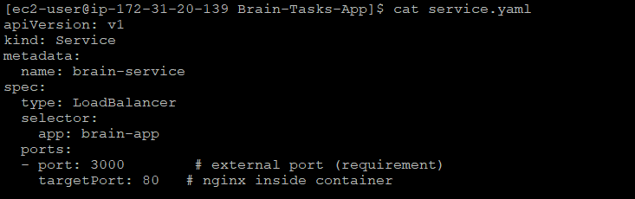

Step 5
CodeBuild created
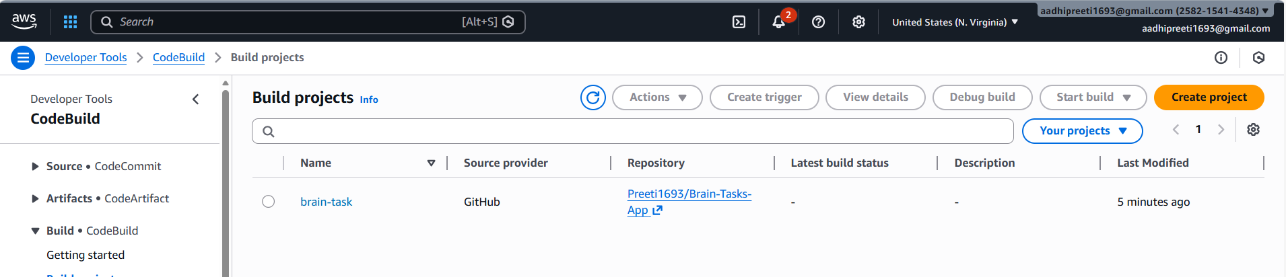

Step 6
Codepipeline created
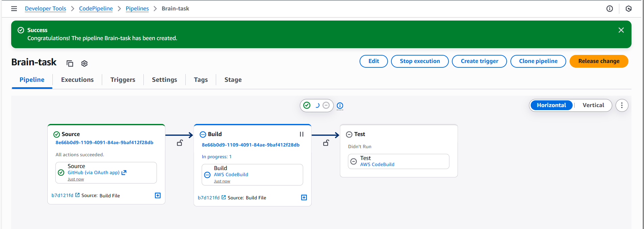
Step 7
Pipeline Executed Successfully
Removed test stage because the code is static React build only
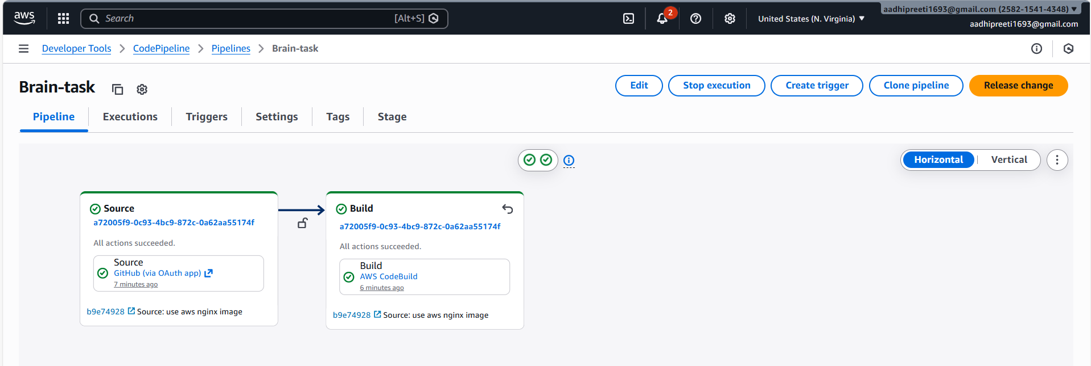
Step 8
Output verification
Images pushed in ECR
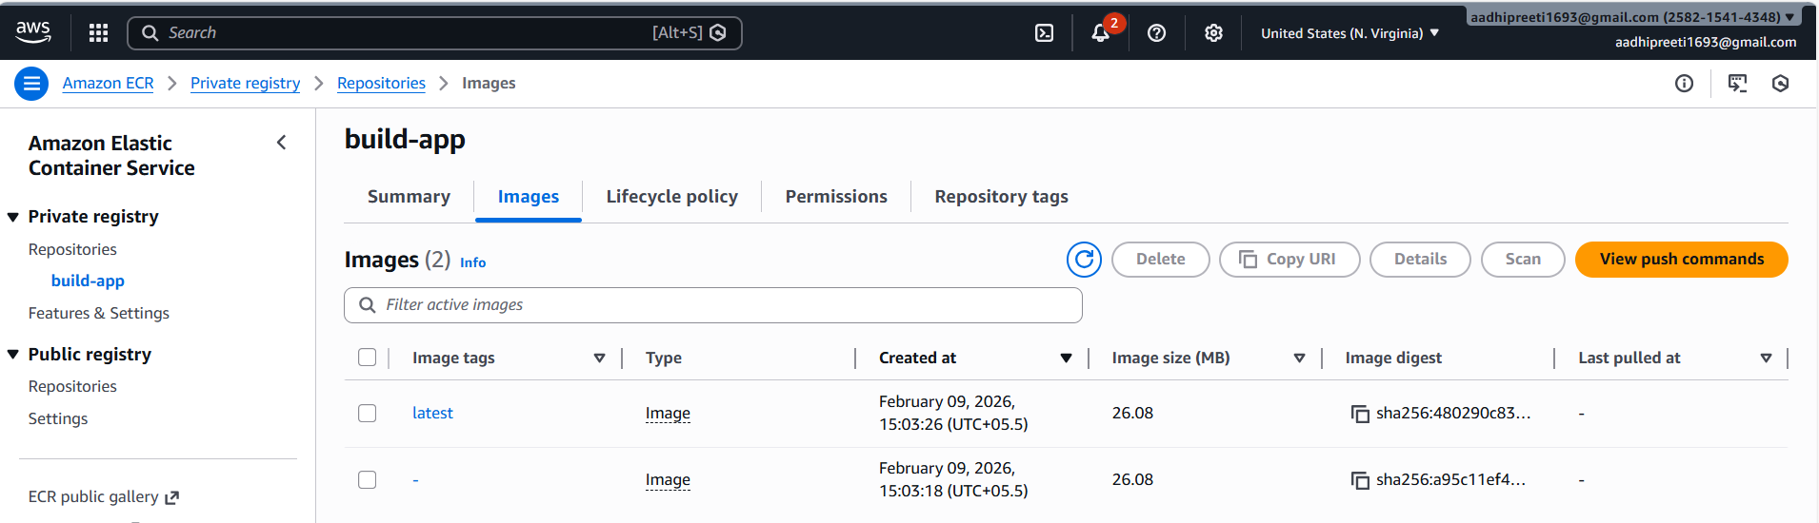
Step 9
Kubernetes created and running
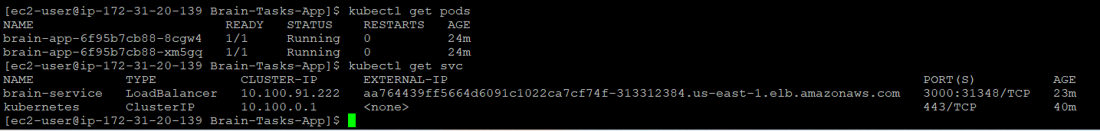
Step 10
Application runs on port 3000
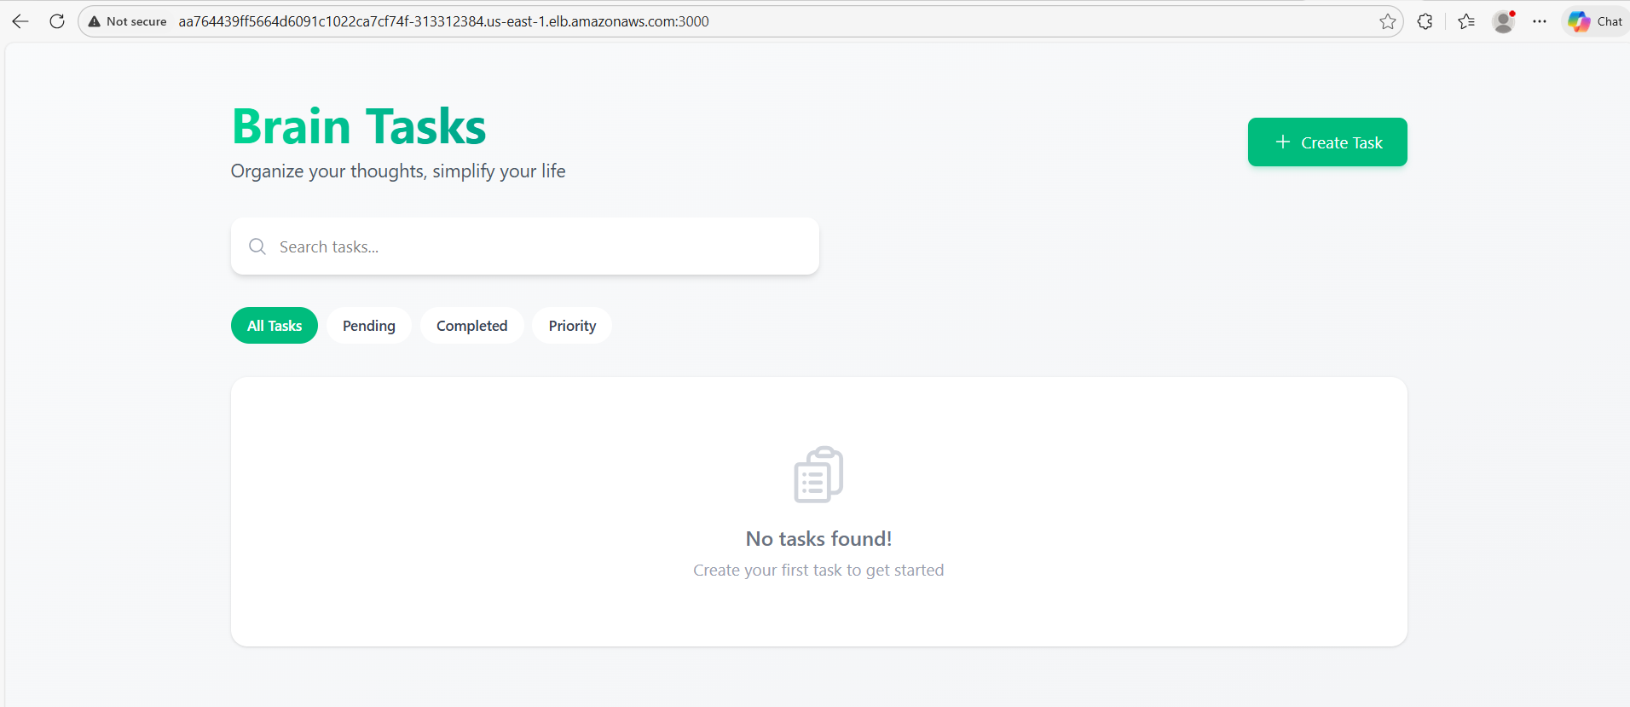

Step 11
Monitoring
AWS cloudwatch
